

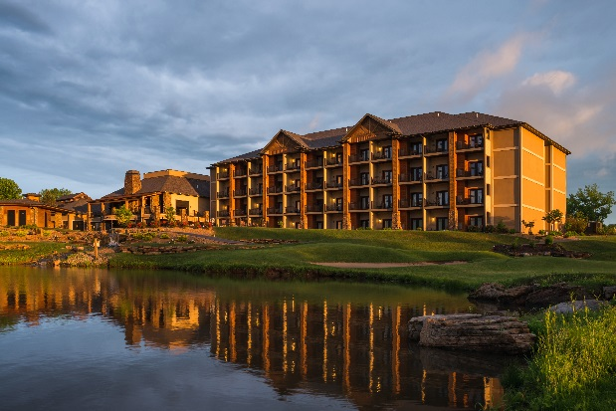 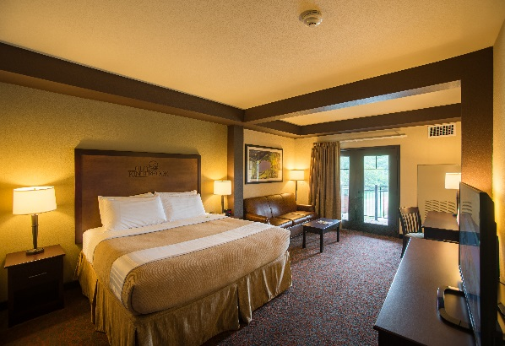

4-2-25

Missouri Mappers Association

Annual Conference August 5-8, 2025

Group Code- 081125MAPP

Rate- $145 per night plus any applicable taxes or fees currently 10.225%

The cutoff date for guestrooms for the above event is July 11, 2025. After this date rooms will only be on a rate and space availability basis. Please use the convenient book now button below or paste the link in your browser. Where it says “Group Attendee” add the above group code and click ”add”. “Click select and go to next screen.” This will be your groups booking page.

To book a room online, you can go directly to: <https://reservations.travelclick.com/97370?HotelID=97370#/guestsandrooms>

If you have questions or wish to book additional nights outside the block please call 573.317.4314 and talk to a reservations specialist. Thank you and we look forward to having you as our guest.